Calculate the profit. Shop A, buys cake for Rs 20 from a baker and sells for Rs 40 in their shop. They buy bread for Rs 10 and sell for Rs 15. They pay Rs 100 per employee per day. They have 2 employees. What is the profit or loss Shop A makes in a day?. There will be 10 customers coming per day. (hint : Input is how many bread/Cake each customer buys, use while/for loop)

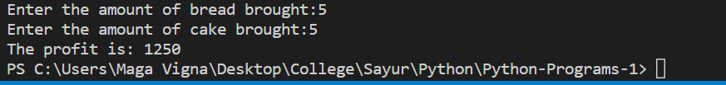

Same as above. Shop A has limited supply of Cake and bread (Hint - supply of Cake/bread should be input, use while stmt for checking the supply)

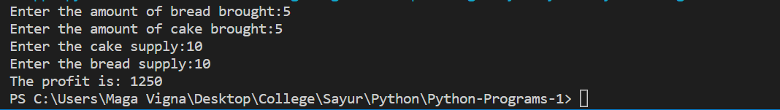

Calculate whether the student passes the degree or not.  Student takes 5 subjects. Student passes a subject if s/he scores above 60%. If the student  scores 90% or above on 3 or more subjects, and 40% or above in other subjects, it is a pass for the degree. If the student scores 75% or above in 3 or more subjects and 50% or above in other subjects, it is pass. All other cases, it is a fail.

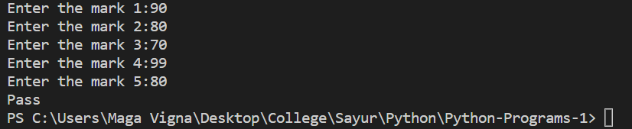

Write a program to find out how many Kg of onion or tomato the customer can buy. One Kg of Onion is Rs 20, Tomato is Rs 10.5.  Input is the budget.



Same as above, but the price of Onion is different based on the city. Chennai - Rs 30, Trichy Rs 27, Madurai Rs 34. Input is budget and city.

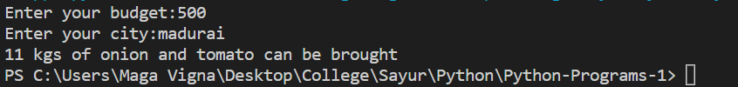

Same as above, but add 3% of the budget for petrol expenses.

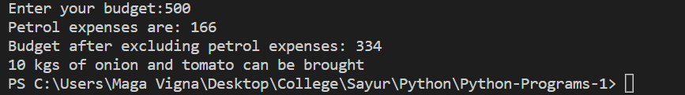

Calculate wedding expenses. Cost for lunch per person is X. Cost for Breakfast per person is half of lunch cost. Cost of the hall is one third of X per person. Decoration is 50% of Hall cost. Parking is 10% of the Hall cost.

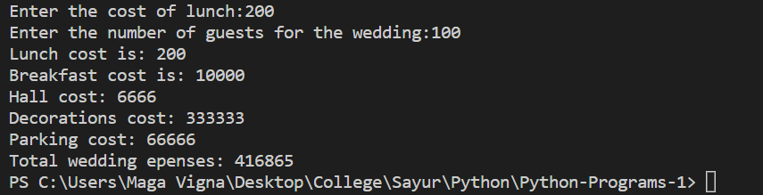

Start with the above. The total cost is split equally by bride and groom. Bride has saved Rs 50,000. Determine if the bride has to take a loan or not. If loan, how much?

